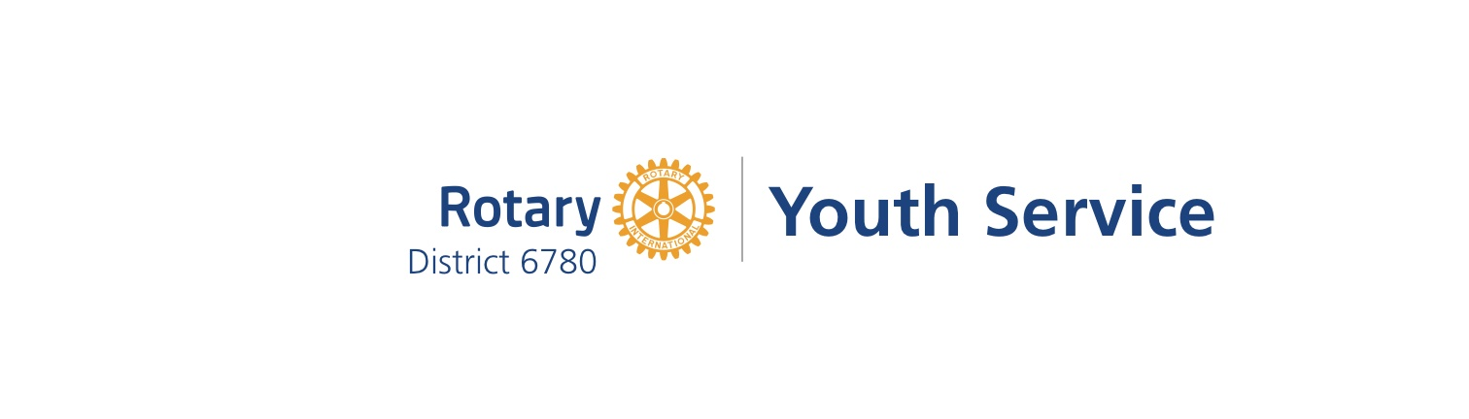

YES AWARD REPORT for 2022-2023

We want to recognize your club for its youth service activities! If your club has participated in at least one of the following, you will be recognized with a YES Award.
E-mail Report to Youth Services Chair, Rachel Moses, at CoachRach@aol.com or can fax to 931-528-9350 or send by regular mail to 1138 Blaine Avenue, Cookeville, TN 38501
- RYLA:
☐ YES – my club sponsored _____ (#) student(s) to RYLA in September 2022.

- Youth Exchange:
☐ YES – my club sponsored an inbound Youth Exchange student during the 2022-23 year.
or
☐ YES – my club sponsored an outbound YE student during the 2022-23 year.
or
☐ YES – my club has recruited an outbound Youth Exchange student for the 2023-24 year.

- Interact:
☐ YES – my club sponsors an Interact Club at _____________________________ (school)
or
☐ YES – my club donated to an Interact Club or worked with Interact Students on a project together.
or
☐ YES – my club has donated at least $100 to the James L. Bomar, Jr., Foundation during this Rotary year.

- Literacy: Examples: Conduct a Literacy or Reading Service Project for Youth in our District, such as participating in Dolly Parton’s Imagination Library, implementing the Dictionary Project, hosting a local Four-Way Test Speech Contest, volunteering to read to children, or many other creative projects that your club may conduct.
☐ YES – my club participated in a Literacy/Reading Project by doing the following:

- Participate in Rotary’s Empowering Girls Initiative: Once again, the RI President’s initiatives is to encourage clubs and districts to prioritize projects that improve the health, well-being, education, and economic security of girls in their communities and around the world. If your club has participated in or developed a club-based initiative, a district grant, or a global grant that engages members of your community in a project that will protect and empower girls, please let us know!
☐ YES – my club participated in an Empowering Girls Initiative by doing the following:

- Other youth-focused community service: Almost every Rotary Club does community service, and usually at least one of the projects is focused on supporting youth. We want your club to be recognized for that youth service, so please tell us what other youth service projects your club does if it does not fit into one of the above sections.
☐ YES – my club provides service to youth by doing the following:

Rotary Club Name:
Club President:
Date Submitted:

Questions??? Contact Rachel Moses at 931-265-0439 or by email at CoachRach@aol.com

